- ​
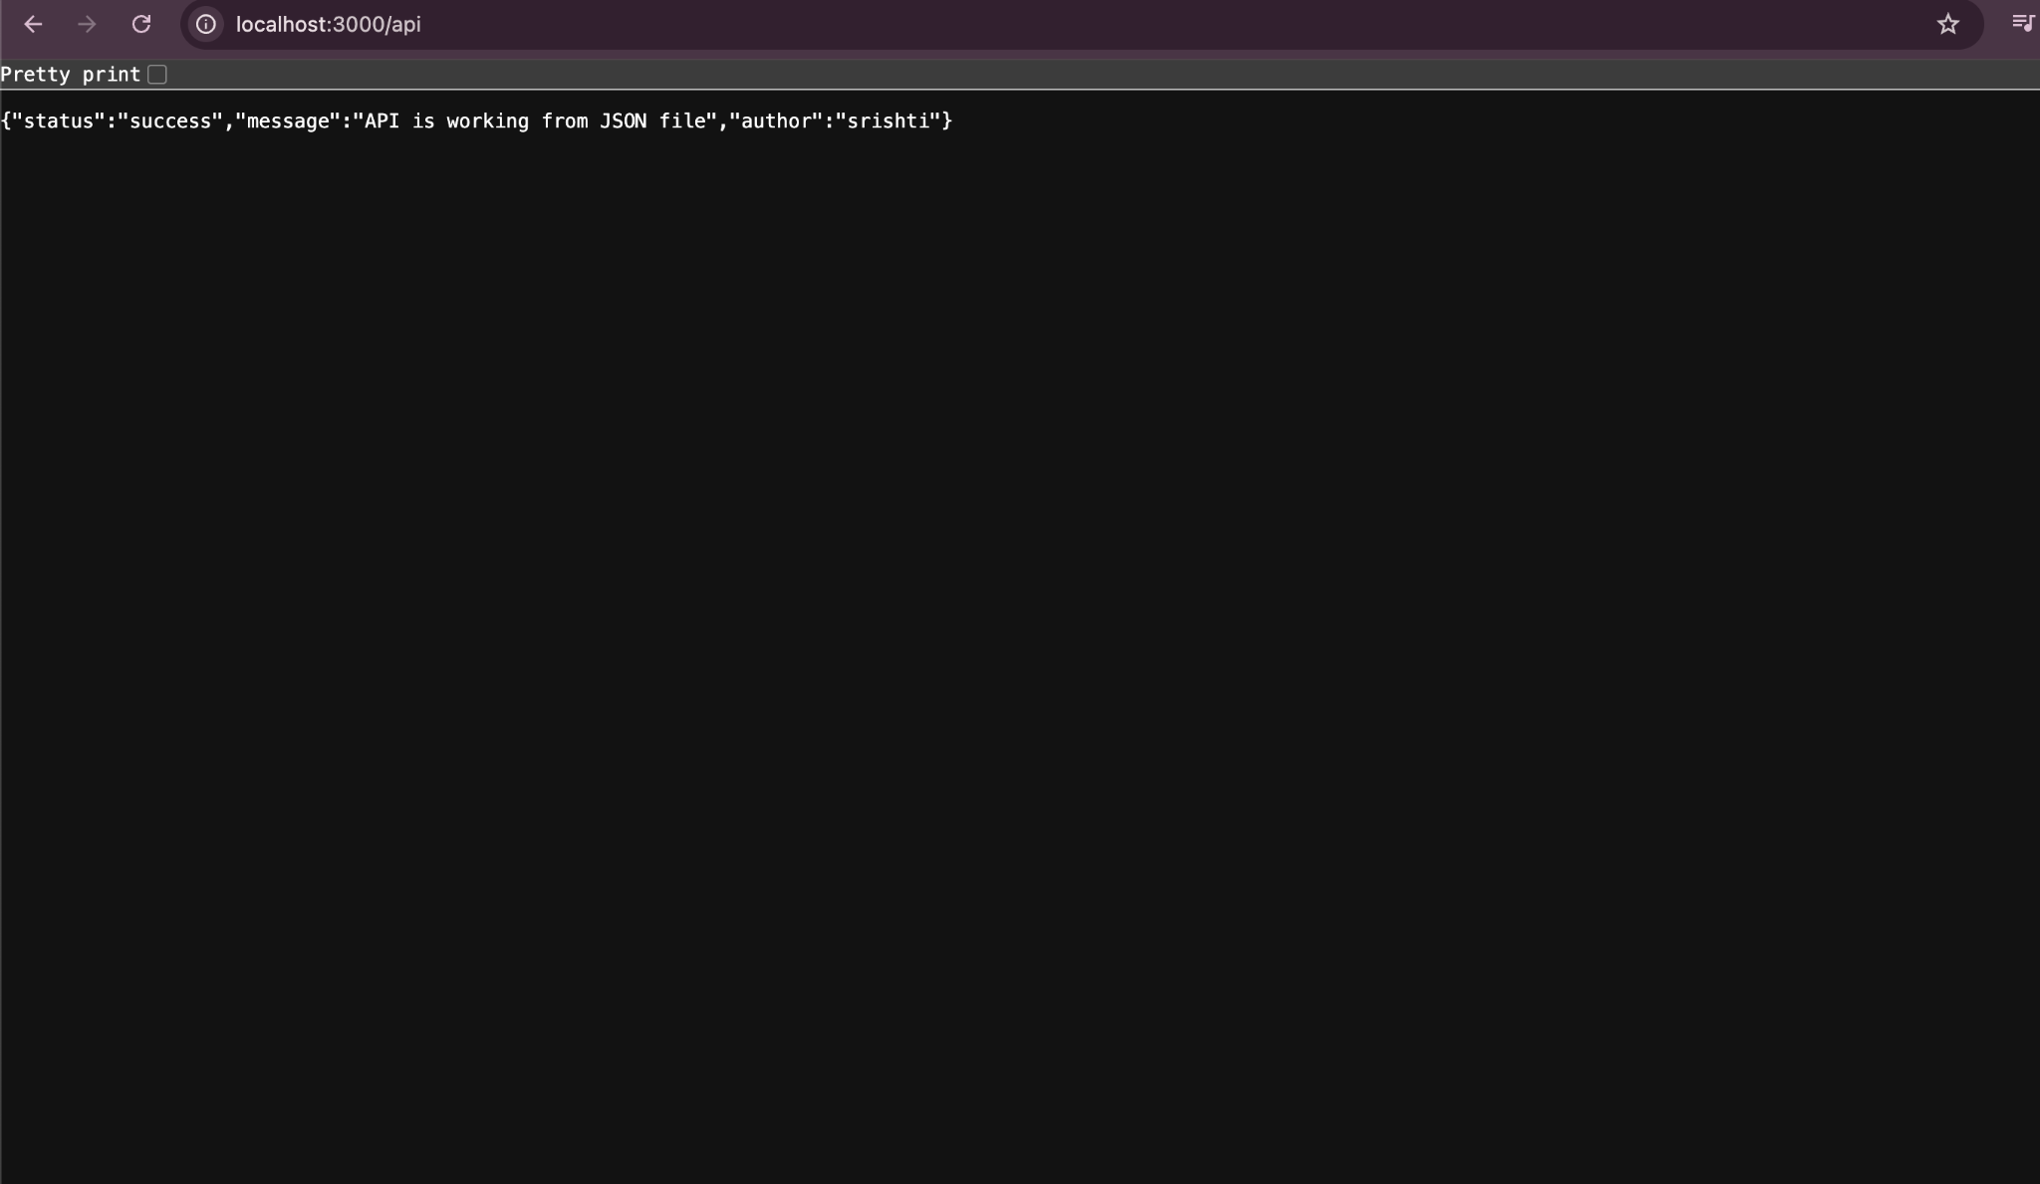

Solution 2.created branch srishti_new , install node , index.js file ., data.json -> response reflected on browser .
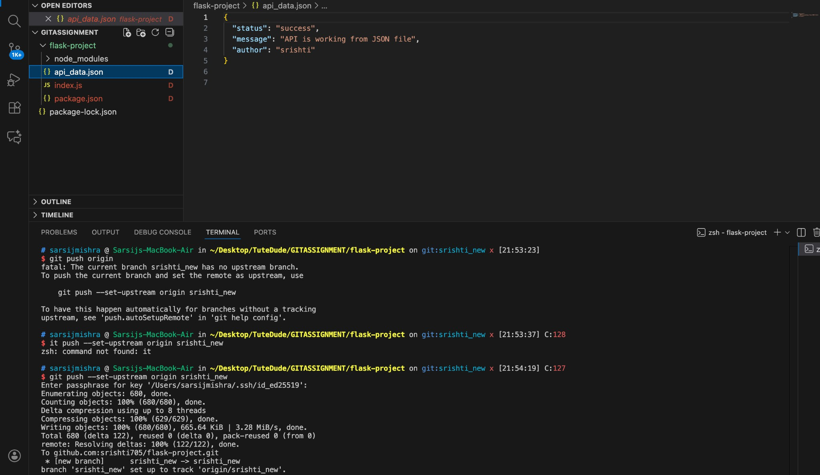

  - Add the resolved changes to the staging area, commit them, and push the updates to the remote repository.
  - 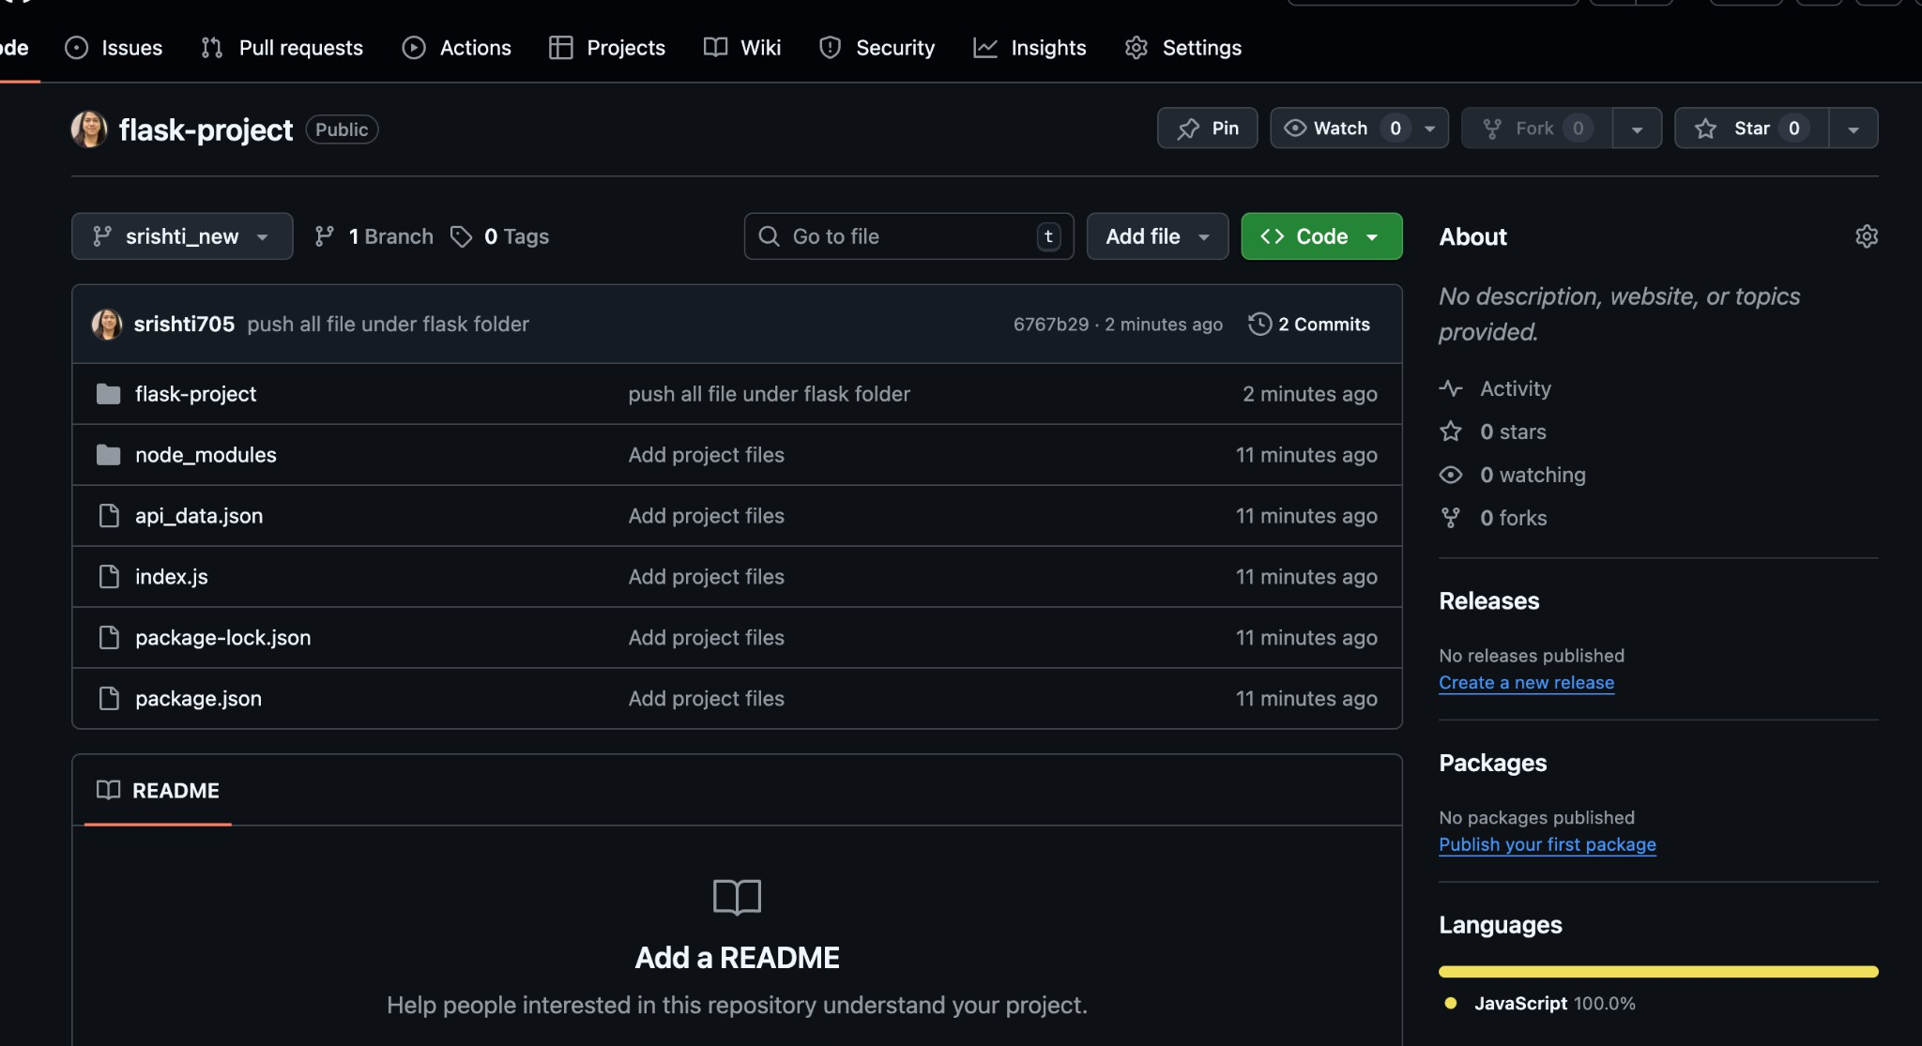 Branch Creation :

Add Item UUID field.

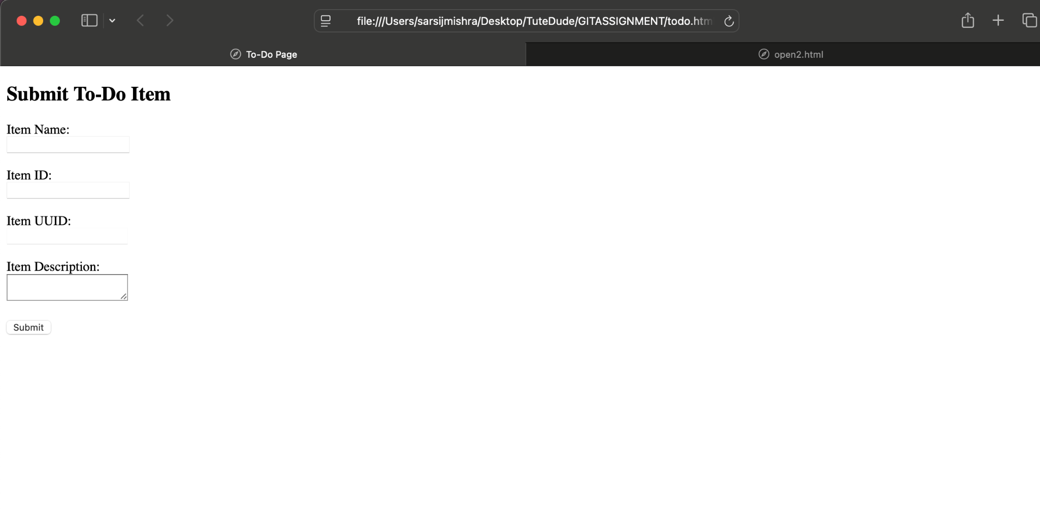

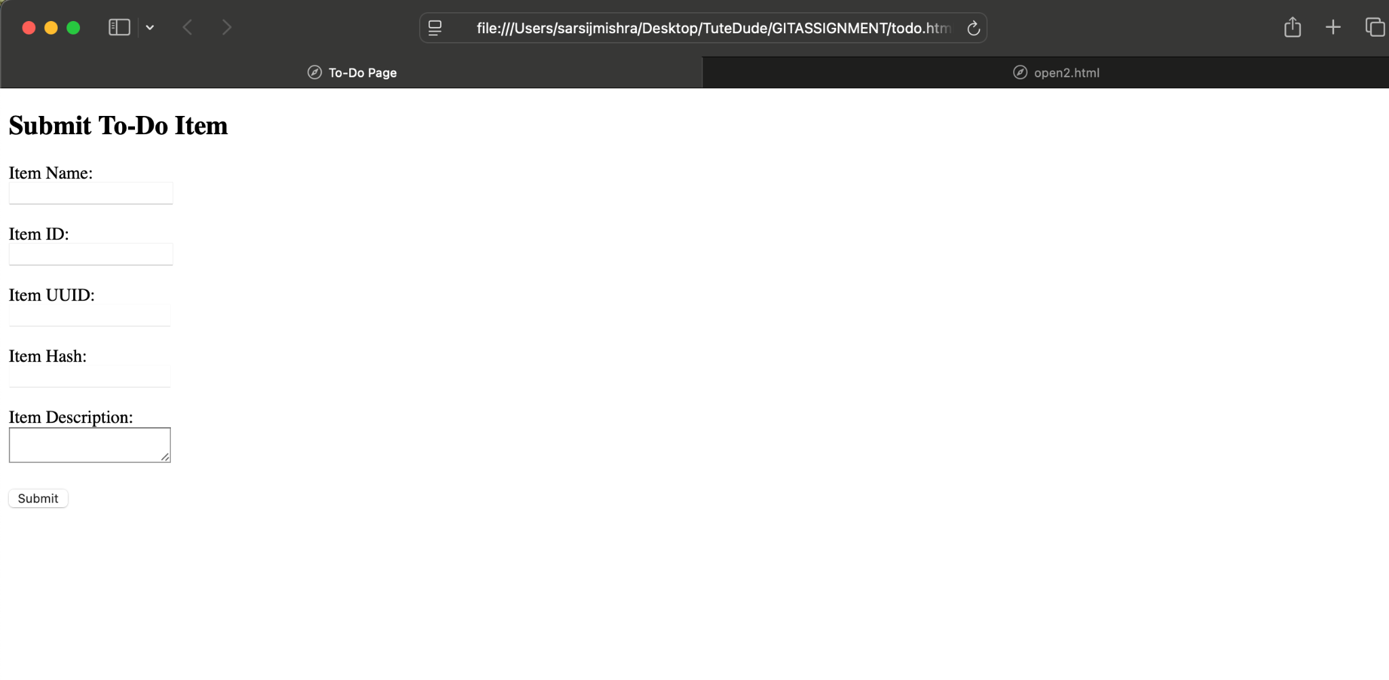

  - Merging to main:
  - Merge the master_1 branch into the main branch.

Git Reset and Commit Deletion:
  - In the main branch, use Git Reset to roll back to the commit where only the Item ID
field was added.
  - Use git reset --soft to ensure changes remain staged.
  - Re-commit this state to the main branch.
  - Merge this updated state to the main branch.

Rebasing Changes:
  - Rebase the updated changes in the main branch to the master_1 branch.

Clarification:
    - During rebasing, preserve individual commits to maintain the commit history for each change (i.e., do not squash commits).
    - Use git rebase main master_1 to integrate changes from the main
branch back into the master_1 branch.

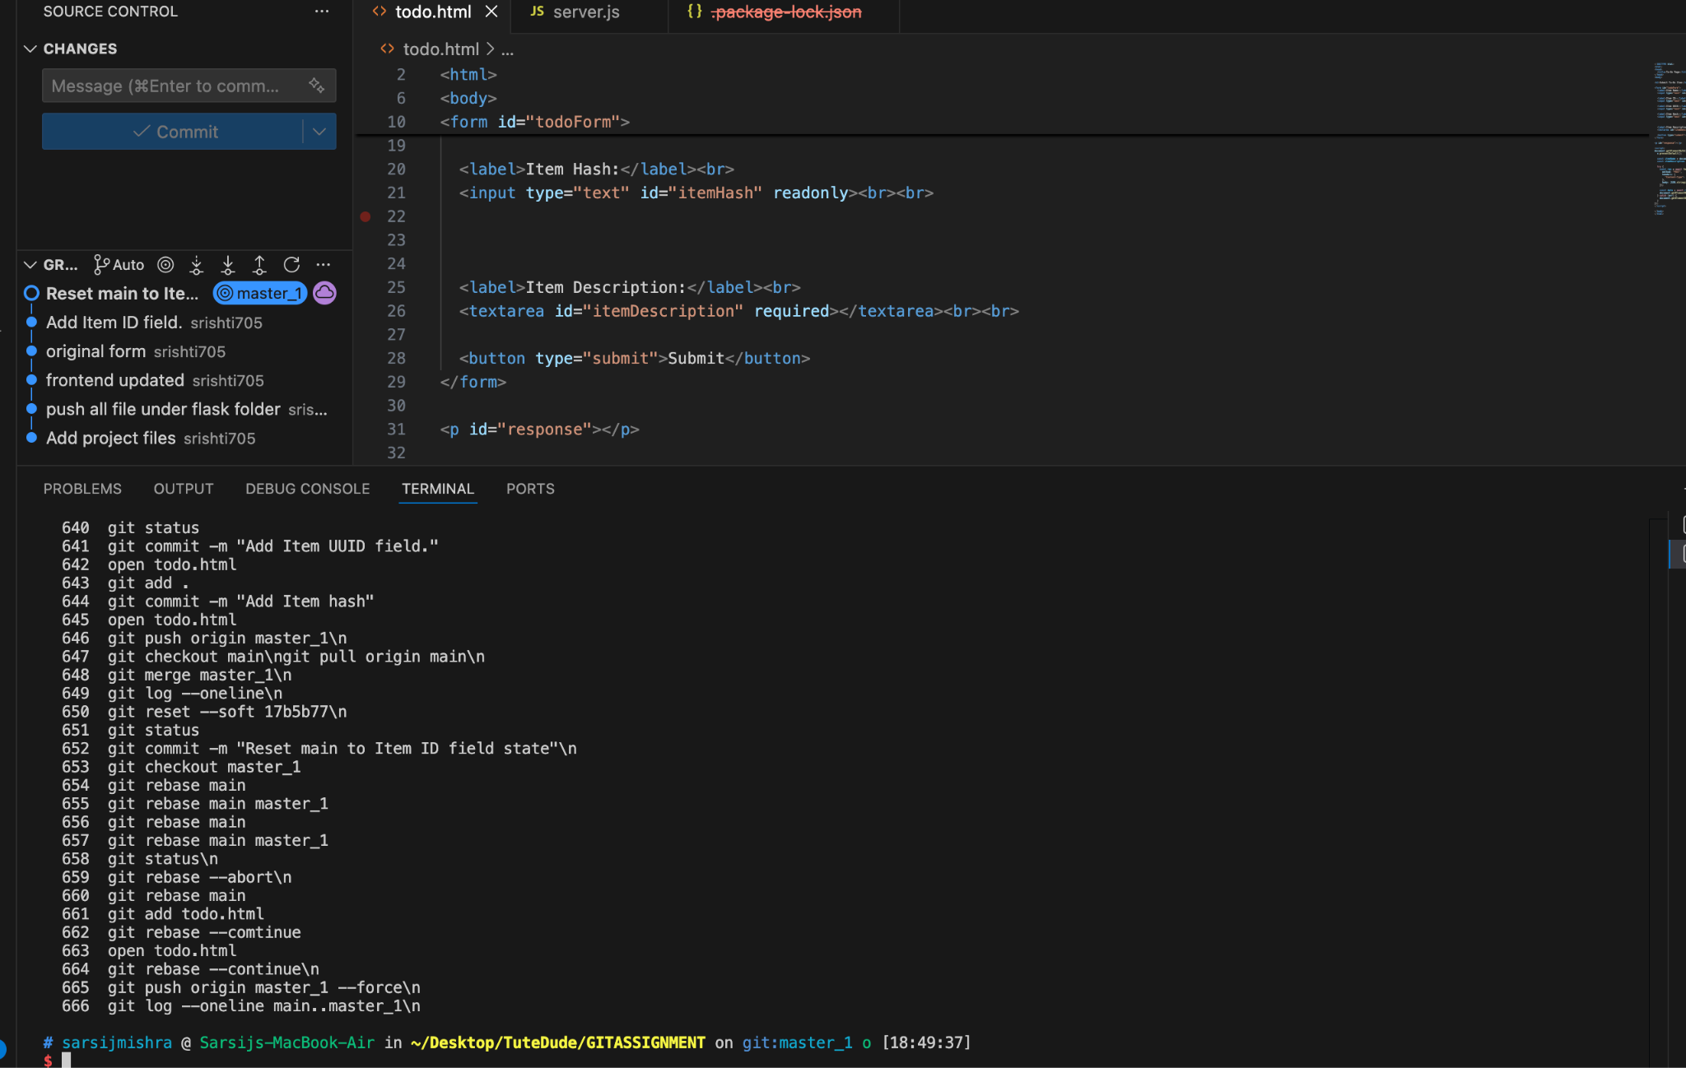

3.
